***Prob 1:***

1. **False**
2. **False**
3. **True**
4. **True**
5. **False**

***Prob 2 :***

1. The belief network for the given case is as follows:

A: Age (young or old)

G: Gender (male or female)

D: Drug (Drug or no drug)

R: Recovery (recover or not)

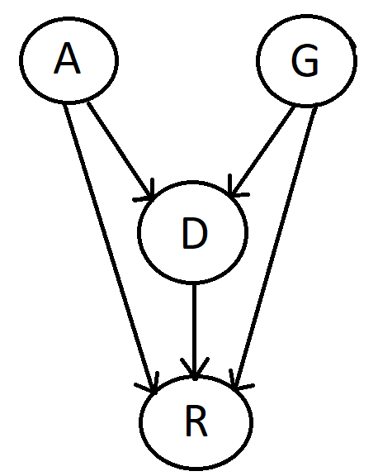

1. ***Yes***, the belief network is a Directed Acyclic graph (DAG). As the graph (shown above) has all edges that are directed and has no cycles( i.e, no nodes are revisited twice having both an incoming and outgoing edge), we can infer that the above network is a Directed Acyclic graph (DAG).
2. The decomposition of joint distribution: P(A,G,D,R) is as follows:

P(A,G,D,R) =>

=> P(R,D,A,G) = P(R|D,A,G) P(D,A,G)

= P(R|D,A,G) P(D|A,G) P(A,G)

= **P(R|D,A,G) P(D|A,G) P(A|G) P(G)**

The required 4 terms showing probability or conditional probability of only one variable are:

**P(R|D,A,G)**

**P(D|A,G)**

**P(A|G)**

**P(G)**